Friction and Gravity

Friction = force that ________________ when the two rub against each other

2 types of friction:  
 1) ___________ - acts on stationary objects experiencing a force   
 2) ___________ - acts on moving objects

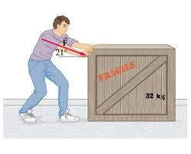

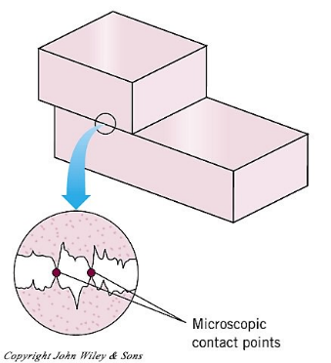

Types of kinetic friction:

1. __________
2. __________
3. Fluid = ___________________

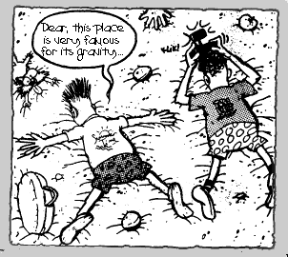

Gravity = force that ___________________________

______________ = the only force acting on a falling object is gravity

- all objects in free fall accelerate at the same rate. Acceleration due to gravity = 9.8 m/s2   
   
Weight = measure of the _____________________________ on an object

Weight = Mass x acceleration due to gravity  
 = mg

= Mass x 9.8 m/s2  
Mass (amount of matter in an object) ______________________, but weight  
  
_________________ depending on the force of gravity.