Objective: Build a wave machine that demonstrates various wave phenomena. Observe and record wave motion as wave characteristics are altered.
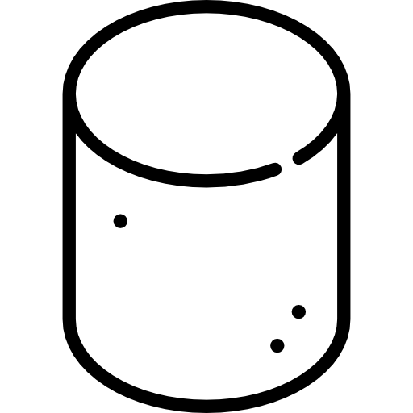
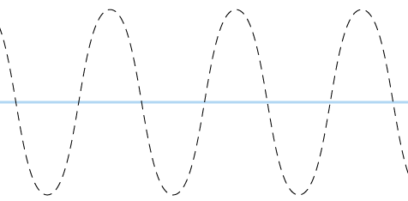
STEP 1 - Supplies:
- 1 Ring Stand
- 1 Meter Stick
- Duct Tape – 1.5 meters
- 50 Wooden Skewers
- 100 Mini Marshmallows
STEP 2 - Setup:
- Place ring stand on table
- Measure 1.5 meters of duct tape
  - Leave about 3 cm on one of the ends for later
- Lay the duct tape flat - sticky side up - secure it with clear tape if needed
- Start placing skewers 3 fingers apart - press firmly so they stick to duct tape. Be sure that each skewer in placed perfectly centered on the duct tape.
- ***Make sure to do this neatly so the skewers line up
- Once all skewers are gone OR you reach the end - secure duct tape on ring stand (sticky side up) leaving the other end free to hold. Return any unused skewers and marshmallows
- Now, carefully add one marshmallow on each side of skewer

STEP 3 - Test your Wave Machine:
- GET YOUR CAMERAS READY!
- Always stop all waves on the machine prior to making the next set of observations.
- A wave pulse is a single burst of energy.
- A periodic wave is generated from repeated motion at a regular time interval (period).
- Have one classmate (Classmate A) hold the free end (tightly)
- Have another student (Classmate B) START the wave (carefully)
- Have 2 classmates record the wave. ( Classmate C & D)
  - Capture: slow-mo and/or full speed, from the ring stand end, and from the side.
- 1 person from your group submit the slow-mo or full speed videos through Schoology

