Activity: Wave Stations
Station 1: Make that wave
Try to make a transverse and then a compression wave using each of the materials. What type(s) of waves were you able to make with……….
A) Slinky
B) Dominos
C) Rope
Suppose that a pirate ship with its treasure sunk in the ocean. After many years, some of the treasure was found close to shore. What type of waves would move the treasure? Explain.

Station 2: Wave Table
1. Using a single bead from the two point source, lightly touch the surface of the water near the middle of the tank.
What was the shape of the wave front? ___________________
2. Place the back edge of the multi-point source in the water and move it forward a small amount.
What was the shape of the wave front? ___________________
3. Use the multi-point source to make a straight wave hit a barrier that you place in the tank. Place the barrier according to the following diagrams. Draw how the wave was reflected.
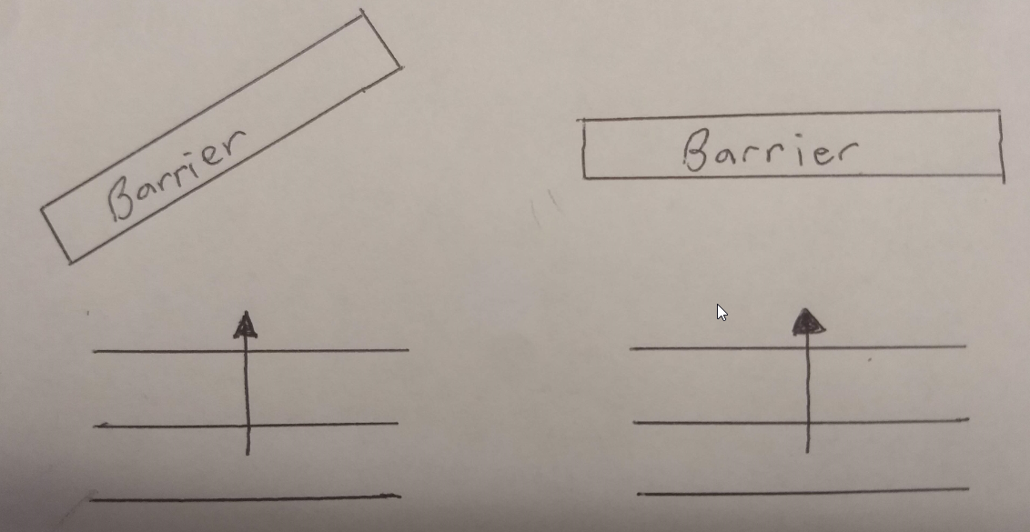
4. Is the wave on the wave table is an example of a transverse or compression wave? _______________________
Station 3: Tuning Forks and Waves
Pitch is related to frequency. The higher the pitch, the higher the frequency. The lower the pitch, the lower the frequency. Use the triangle to hit each of the tuning forks (long, medium, short).
Which fork had the highest pitch? ____________ Lowest? ____________
Now look at each tuning fork and find the number stamped on it. That number is the frequency.
Long: ________ Hz
Medium: ________ Hz
Short: ________ Hz
Use the triangle to hit each of the tuning forks and then lower them into the water to make water waves. Is there any difference in energy transfer between the different tuning forks?
Station 4: Milk Container-Reflector
Talk in different voices into the end of the milk carton while another student shines a flashlight on the mirror at an angle that reflects it on the wall. What happens to the light on the wall when the student is talking?
Object | Volume:  Did the waves change when the student talked loudly or softly? | Pitch:  Did the waves change when the student talked high or low? | Frequency:  Did the sound waves vibrate fast or slow?
Light on the wall
Station 5: Rubber Bands on Doorknob
Fasten a rubber band to a doorknob, pull it taut, and pluck it. Repeat several times with different tension to doorknob and different force plucking. These vibrations are similar to what goes on in your vocal chords when you talk.
Object | Volume:  How could you make the volume….. | Pitch:  How could you make the pitch…… | Frequency:  Did the rubber band vibrate fast or slow?
Rubber Band | Loud:  Soft: | Low:  High: | Low Pitch:  High Pitch:
Station 6: Boom Box
1. Place a blown-up balloon on top of the computer speakers and rest your hand on the balloon.
2. On the laptop, click “Sound File 1”. Start turning up the volume and record what happens to the balloon in the data table.
3. With the volume still turned up, play “Sound File 2”. This file will start at a low frequency and gradually increase to a high frequency. Record what happens in the data table.
4. Repeat steps #2-4 replacing the balloon with a paper plate with small pieces of paper on it on top of the speakers.
Object | Volume:  What happened to the object when the volume was turned up? | Frequency:  Did the objects vibrate fast or slow?
Balloon |  | Low Pitch:  High Pitch:
Paper |  | Low Pitch:  High Pitch:
Station 7: Reflection from a Plane Mirror
When a wave hits an object, it can bounce off or pass through. Bouncing off is called reflection. In this activity, you will study the reflection of light off a mirror.
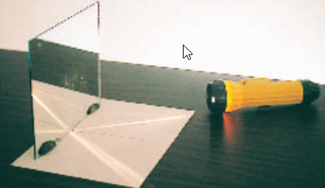
1. Turn on the flashlight and place it so the beam is along the 60⁰ line aiming towards the center of the protractor and mirror. This is called the angle of incidence.
2. Measure and record the angle that the reflected beam makes with the mirror. This is called the angle of reflection.
3. Repeat for 45⁰ and 30⁰
Angle of Incidence | Angle of reflection
60⁰
45⁰
30⁰
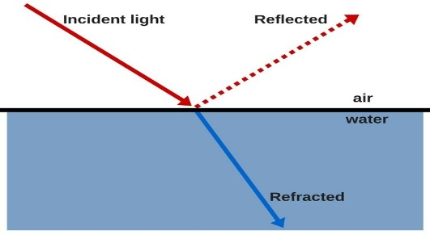
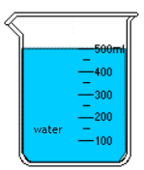
From your results, what is the relationship between the angle of incidence and angle of reflection?
Station 8: Refraction through air, water, and oil.
Look at the room through the beaker filled with water and notice that everything looks distorted and uneven. This has to do with the way light travels through glass, water, and other transparent materials. When light moves through a material, it is slowed down. When light is slowed down, it either bounces off the material or is bent as it passes through. We can see these changes in light, which indicates to us that something is there.
However, when a transparent object (plastic drinking straw) is surrounded by another material (oil) that bends light the same way, you will not be able to see the object (as easily). In this activity you will play with light to make normal objects appear and (almost) disappear!
1. Cover the top of the straw with your finger to prevent liquid from filling it and immerse it in the beaker of water. What do you notice about the straw? Can you still see it? How clearly?
2. Keeping the straw in the water, release your finger from the top to allow the immersed straw to fill with water. Did anything change about the straw once it was filled with water? Does the straw become easier or more difficult to see once it is filled with water?
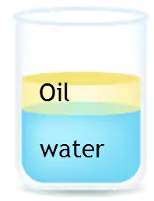
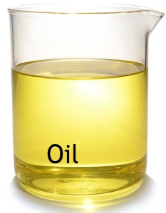
3. Using a separate straw, cover the top of the straw with your finger to prevent liquid from filling it and immerse it in the beaker of oil. What do you notice about the straw? Are you still able to see it? Was it easier to see the straw when it was in the water?
4. Keeping the straw in the oil, remove your finger from the top to allow the immersed straw to fill with oil. What happened? Can you still see the straw? Is it easier or more difficult to see it now than it was when it was empty?
5. Fill the straw with oil from the oil beaker and hold your finger over the top so it doesn’t leak out. Then slowly immerse it into the beaker with water and oil, so that the straw is visible in both the water layer and the oil layer. Look at the straw in the water layer, then in the oil layer. What is different about the straw in these two layers? Is it easier to see the straw in the oil or the water?
6. Uncover the top of the straw to release the oil into the beaker. Then fill the straw with water from the water beaker and hold your finger over the top so it doesn’t leak out. Slowly immerse it into the beaker with water and oil. Is it easier to see the straw in the oil or in the water this time?
**TEACHER NOTES**
station 2 – make something like this: https://www.flinnsci.com/water-waves/ap4611/
station 4 – cut a large hole in the side of a milk container and cover it with a piece of tissue paper. Place a small mirror on the middle of the paper.
station 6 – “Sound file 1” = any song
“Sound file 2” = Human audio spectrum (low to high) (up to about 50 sec) https://www.youtube.com/watch?v=qNf9nzvnd1k
Use computer speakers pointed upward. Place balloon/plate directly on top.
Station 7: tape a piece of paper with a small slit on it to the flashlight. That way only a narrow beam of light will be seen.
protractor print out to use (make it as big as whole page)
